**About Checklists**

Checklist type compliances are grouped under Checklist. Checklist compliances are performed and does not require a review. You can also update status of multiple checklists at a time.

1. On the main menu, click ***My Workspace*** and then click ***Checklist***. The ***My Workspace/Checklist*** screen appears as shown in the figure:

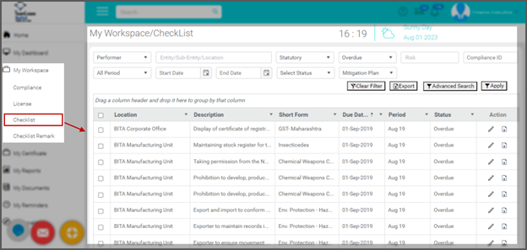

1. Use filter options and advanced search to find compliances. Click here to see how to:
   * Use filter option in My workspace
   * Use advanced search in My Workspace

Performing Checklist Compliances

Based on the configuration, the checklist compliances will appear on the dashboard with statutory and internal count under ***Checklist***. Alternatively, will be listed with the regular compliances under ***Upcoming*** and ***Overdue*** counts.

To perform checklist compliance, follow these steps:

1. On the Dashboard, under ***Performer Summary***, under ***Checklist***, click on the ***Statutory*** / ***Internal*** count as shown in the figure:

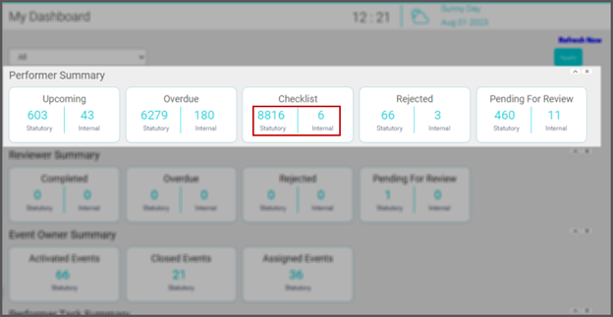

1. The ***My Workspace*** screen appears with list of Checklist compliances as shown in the figure:

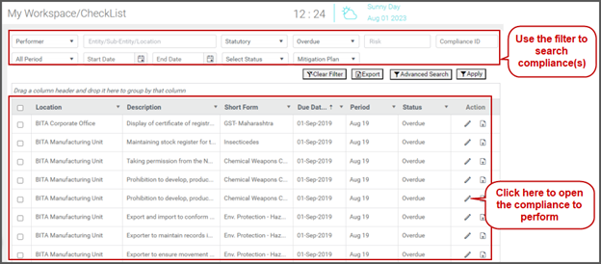

1. Use filter options and advanced search to find compliances. Click here to see how to:
   * Use filter option in My workspace
   * Use advanced search in My Workspace
2. In the ***Action*** column, clickcontents/assets/images/image350.png  to perform the compliance. The selected compliance opens as shown in the figure:

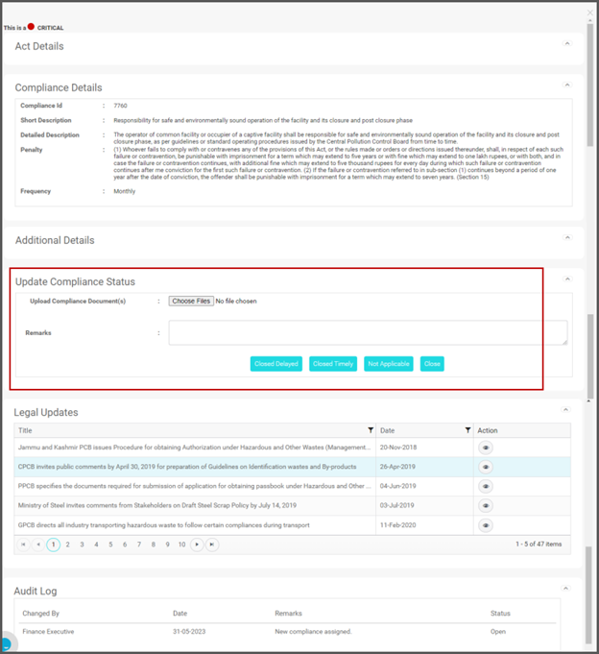

1. You can see the following sections:
   * ***Act Details***: This section displays the Act details the compliance belongs. Details such as Act name, Section / Rule, Act Documents appears. You can view or download the Act documents.
   * ***Compliance Details***: This section displays the compliance details such as Compliance Id, Short Description and Detailed Description and Frequency of the compliance.
   * ***Additional Details***: In this section, you can see the Risk Type, Sample Form/Attachment, Regulatory website link, Additional/Reference Text, Location, Period, Due Date and Audit Checklist details.
   * ***Update Compliance Status***: You will update this section while performing and reviewing the compliance.
   * ***Legal Updates***: This section enables you to view legal updates related to the compliances.
   * ***Audit Log***: This section displays audit log of the compliance
2. Under ***Update Compliance Status***, fill the following fields as shown in the figure:

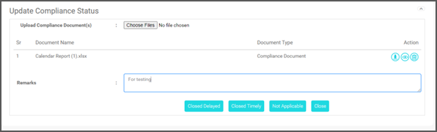

1. In the ***Upload Compliance Document(s)*** field, click ***Choose File*** and upload the documents. Once uploaded, you can do the following:
   * Clickcontents/assets/images/image354.png to download the document.
   * Clickcontents/assets/images/image355.png to view the document.
   * Clickcontents/assets/images/image356.png to delete the attached document.
2. In the ***Remarks*** field, type your remarks.
3. Click ***Closed Delayed*** / ***Closed Timely*** / ***Not Applicable***.
4. Click ***Close*** to close the compliance. The compliance status is updated and does not require a review.

**Update Status of Multiple Checklist Compliances**

Based on the configuration, the checklist compliances will appear on the dashboard with statutory and internal count under Checklist. Alternatively, will be listed with the regular compliances under Upcoming and Overdue counts.

To update status of multiple checklist compliance, follow these steps:

1. On the Dashboard, under ***Performer Summary***, under ***Checklist***, click on the ***Statutory*** / ***Internal*** count as shown in the figure:



1. The ***My Workspace*** screen appears with list of Checklist compliances as shown in the figure:

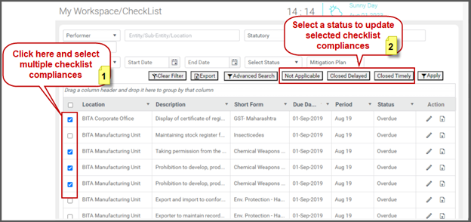

1. Click to select multiple checklist compliances as shown in the above figure.
2. Click ***Closed Timely*** / ***Closed Delayed*** / ***Not Applicable*** to update the status. The status of the selected compliances is updated.

Generally, the checklist compliances do not require review. Hence, will be closed by the Performer and do not go to the Reviewer queue.